**grep Assignment**

1. **Use any .c file. Using grep command extract and display**
2. **all lines beginning with #include with line numbers**

**Ans**: here is a file named p1.c

TO display all lines beginning with #include with line numbers

**grep -n '^#include' p1.c** command is used



**b. display all lines which do not begin with #include**

**Ans:** To display all lines which do not begin with #include

**grep -vn '^#include' p1.c** command is used

**c. display the line number of main()**

**d. extract all lines containing characters of opening and closing parathesis {(,))**

**Ans :**To display allthe line number of main()

**grep -n 'main()' .c** command is used

**Ans :**To extract all lines containing characters of opening and closing parathesis {(,)}

**grep '[{}]' .c** command is used

**2. Perform the above operations on a set of *.c files**

TO display all lines beginning with #include with line numbers

**grep -n '^#include' *.c** command is used

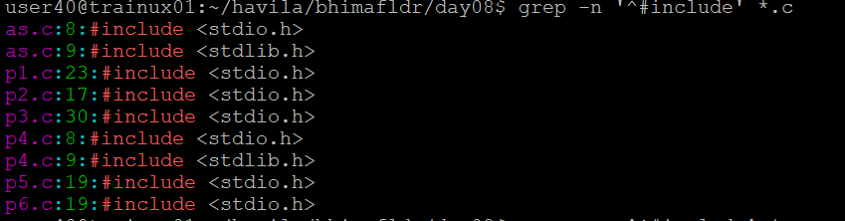

To display all lines which do not begin with #include

**

To display allthe line number of main()

**grep -n 'main()' *.c** command is used

To extract all lines containing characters of opening and closing parathesis {(,)}

**grep '[{}]' *.c** command is used

